**Analysis of Data and Creating Dashboard**

You can analyse the data using the DQL (DNIF query language). The link s given which can give full idea and working DQL (Dnif query language)

**<https://dnif.it/docs/>**

Now, to create dashboard which gives the whole analysis of the our data within one screen. We have to follow following steps.

1. First off all create the package. For that click on “Repository” of “Management” tab.

The screenshot for this is given below.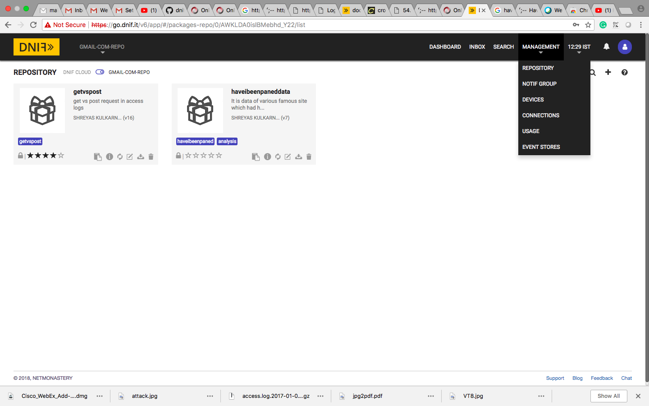

2. Now click on the add button “+”. You get the screen given below. In this screen enter the package details i.e Name for the package, Description, Tags, package image etc. Package image should be of 100 * 100 px.

3. Now save the package details by clicking on the save button which id below right side of the screen.

4. Now to create any dashboard to analysis the data go to the search option and write a dnif query. We have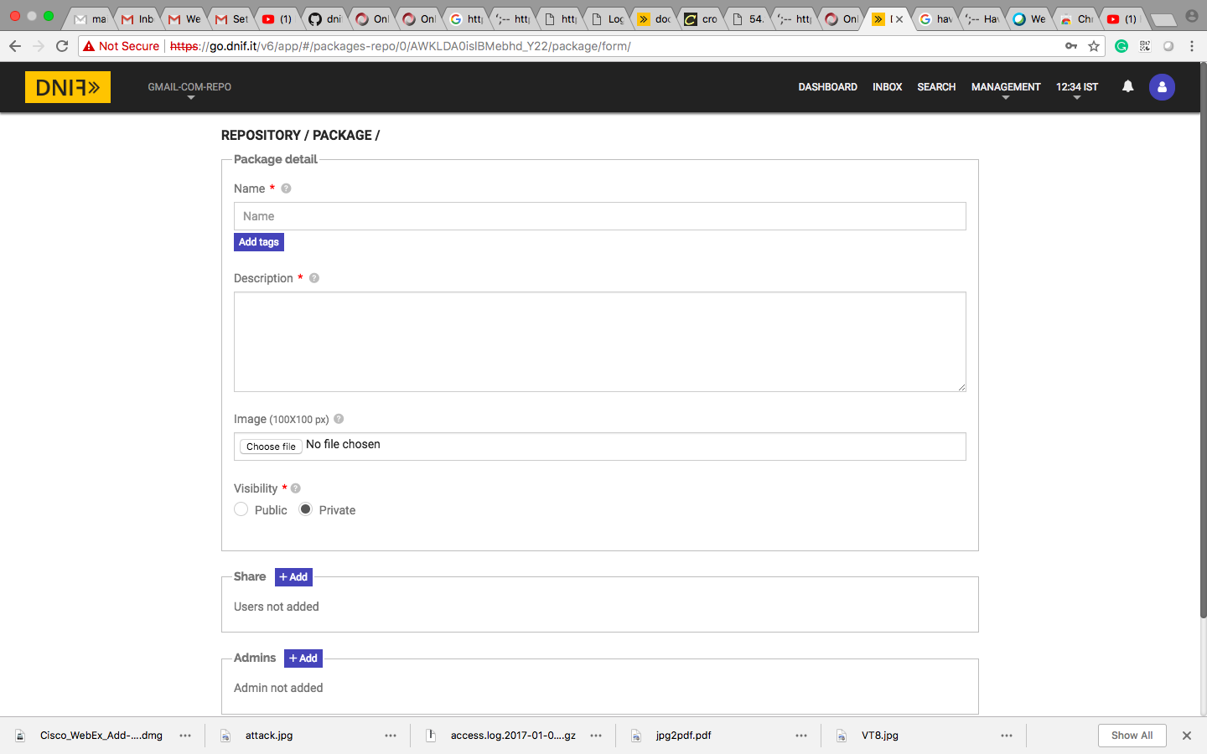 written the query as given below

_**fetch * from fullaccesslog limit 100 >>_agg count_unique $url**

This gives the result of the url and how many times it hits on the server from our access log data.

5. After that create widget for that click on to the click on option button which is like three p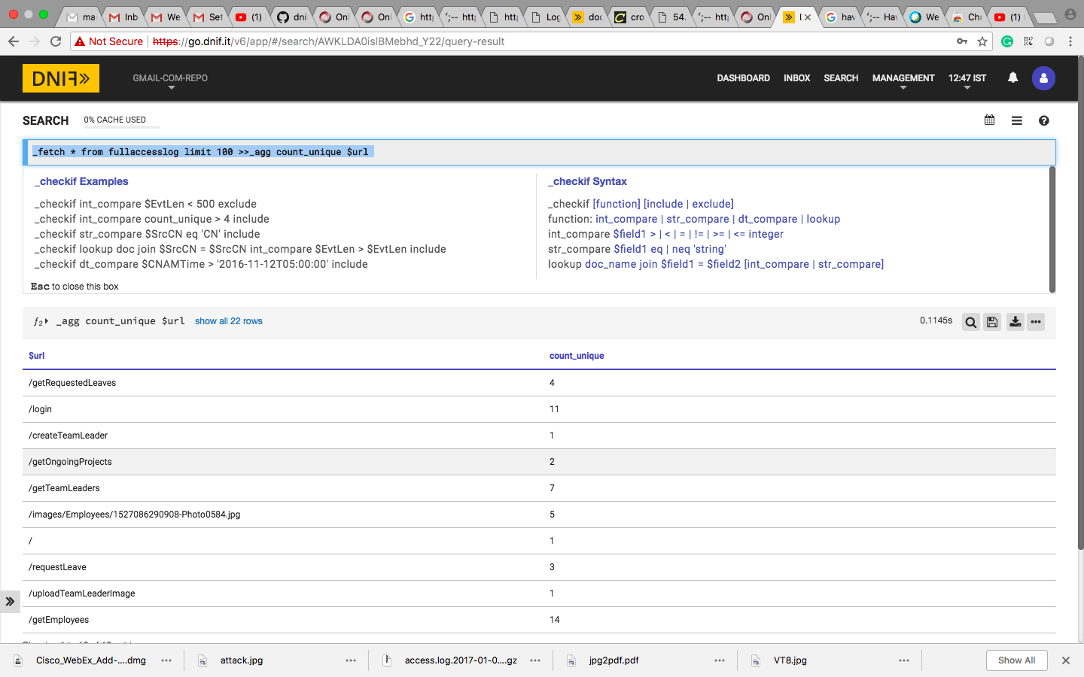arallel dots above the quay result.

After clicking on “Create Widget” we get the following screen.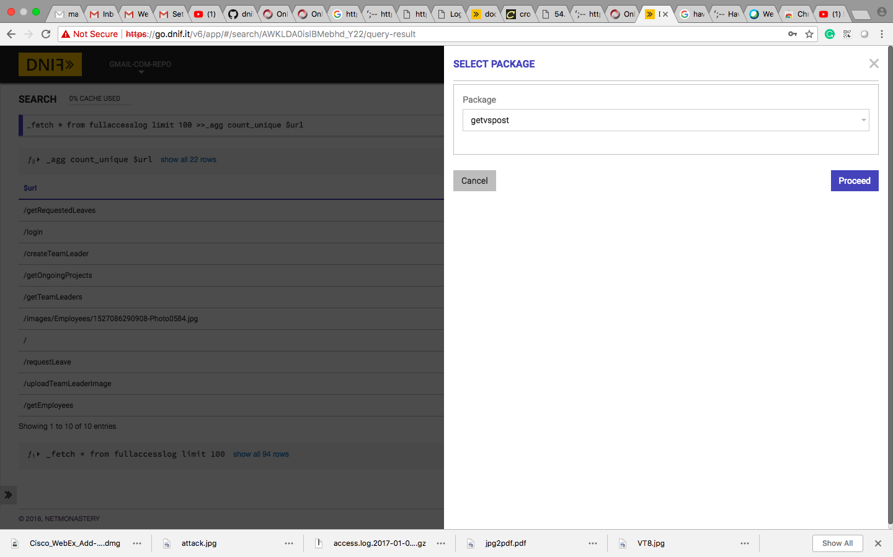

6. Now select the package on which package you want this analysis or widget. and click on proceed. You found the following screen.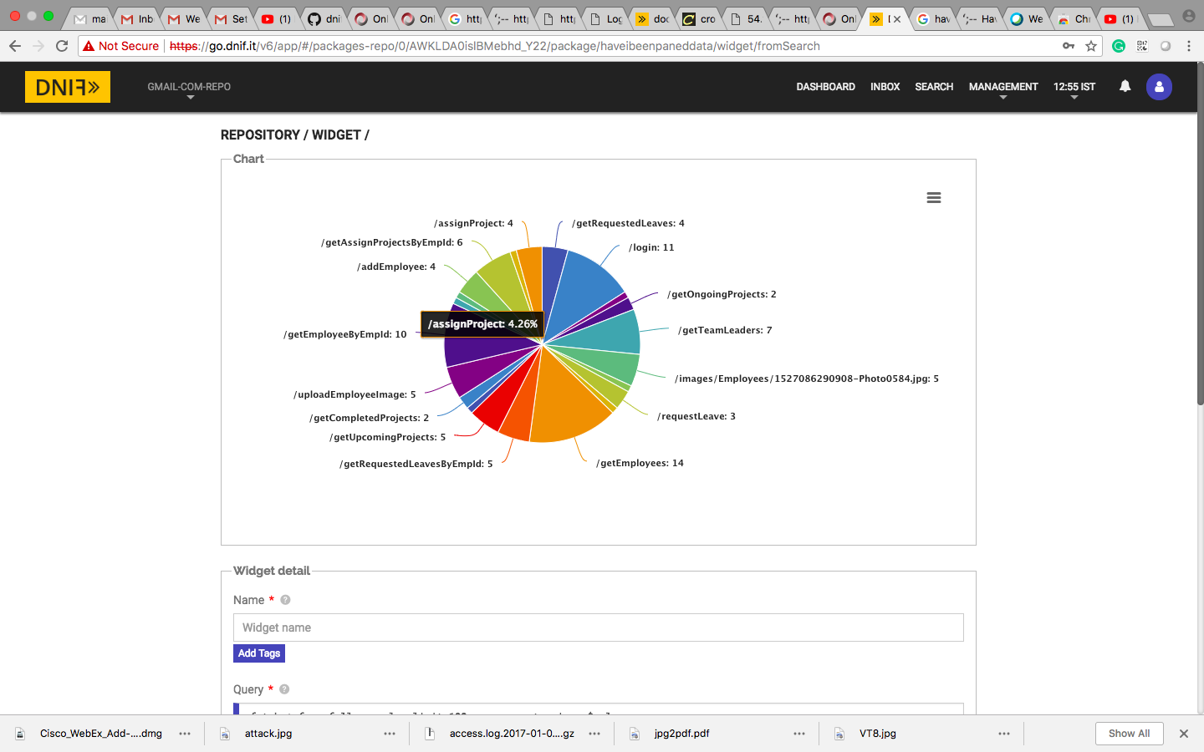

7. Select the chart type which you want too showcase. I have selected “Vertical Bar Chart” option and clicked on the “Create Chart” button which gives me chart given below. Now you can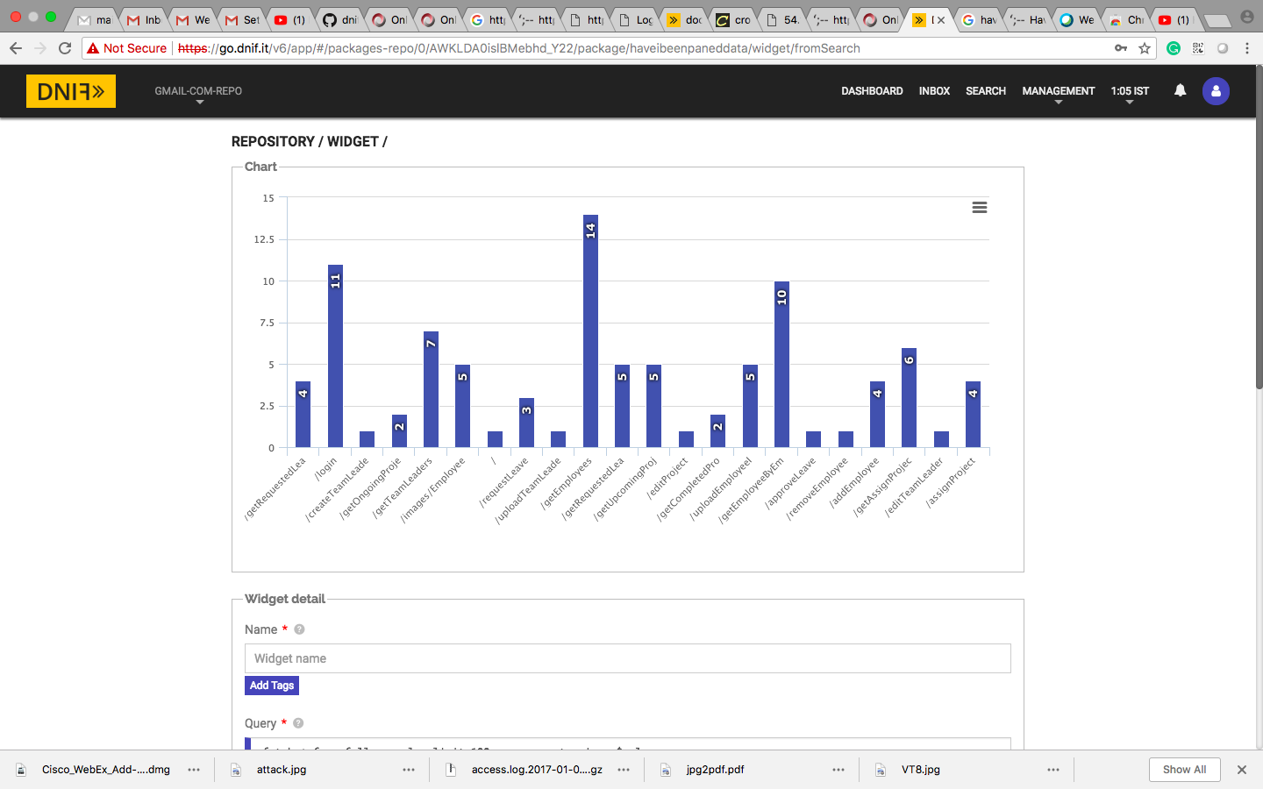

8. Now if you want to add that things in your dashboard. Go to “Dashboard” and click on “+” button.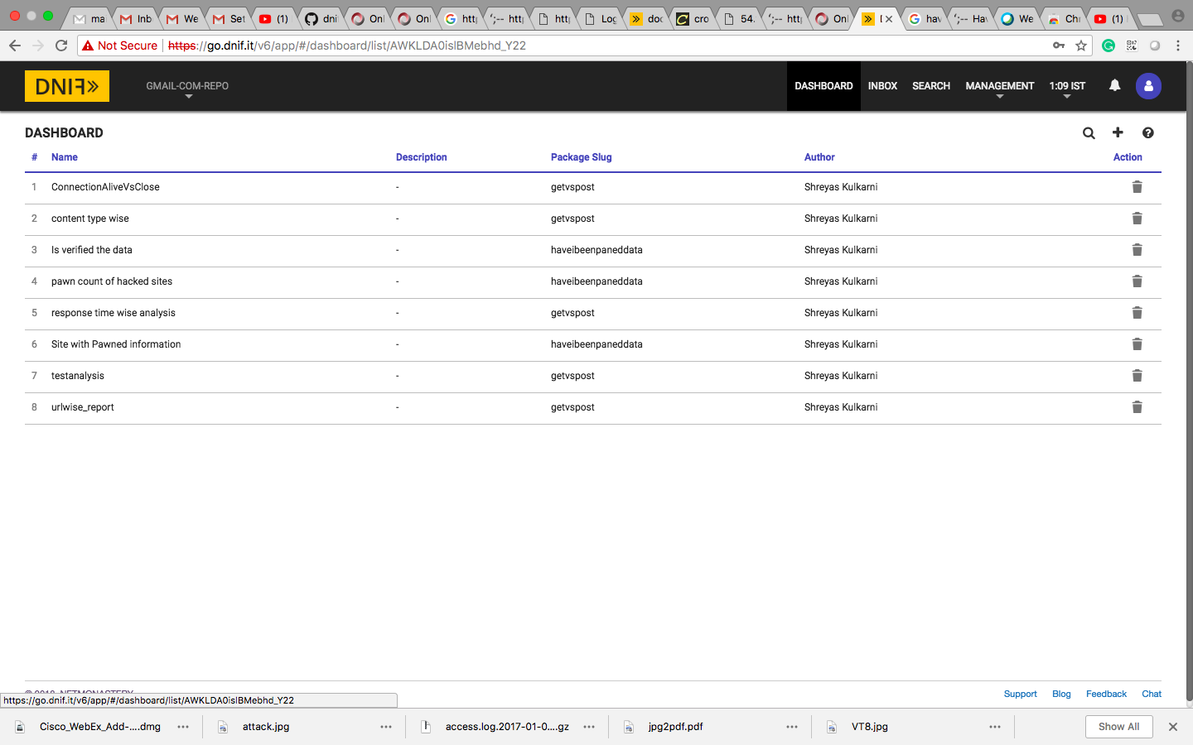

9. You get the following screen in it select the package on which you want to add. The screen is given below.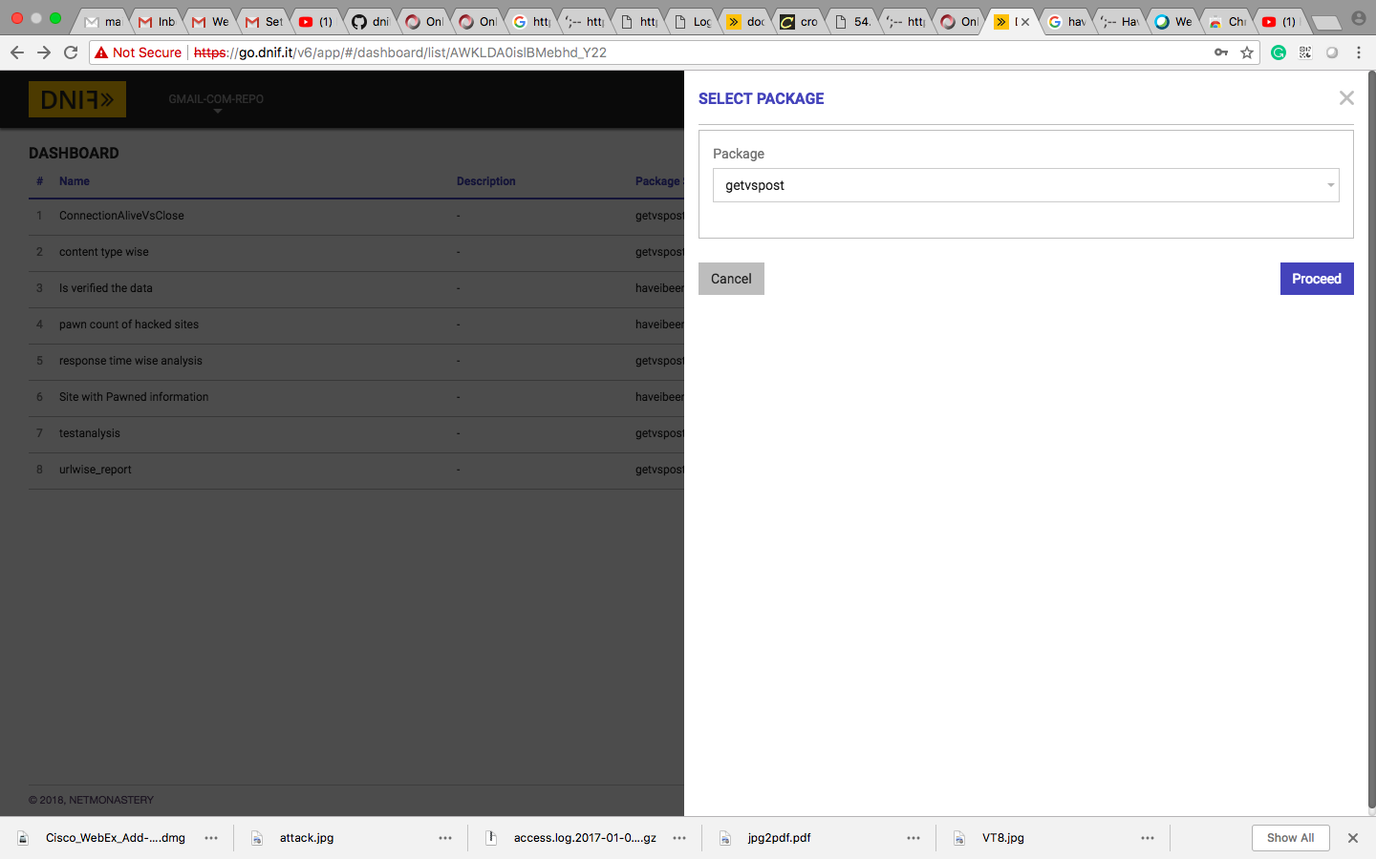

10. Now enter all the information in below screen and click on save button. Your new analysis is get added added in dashboard.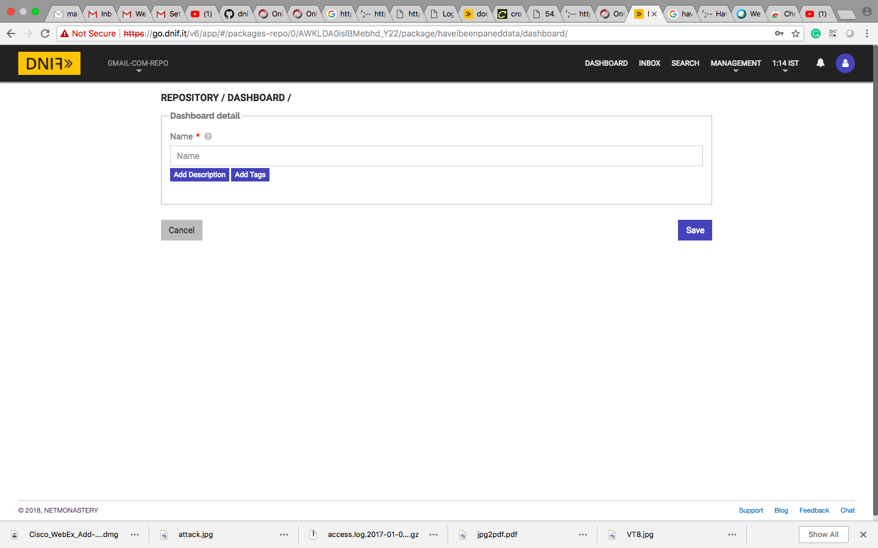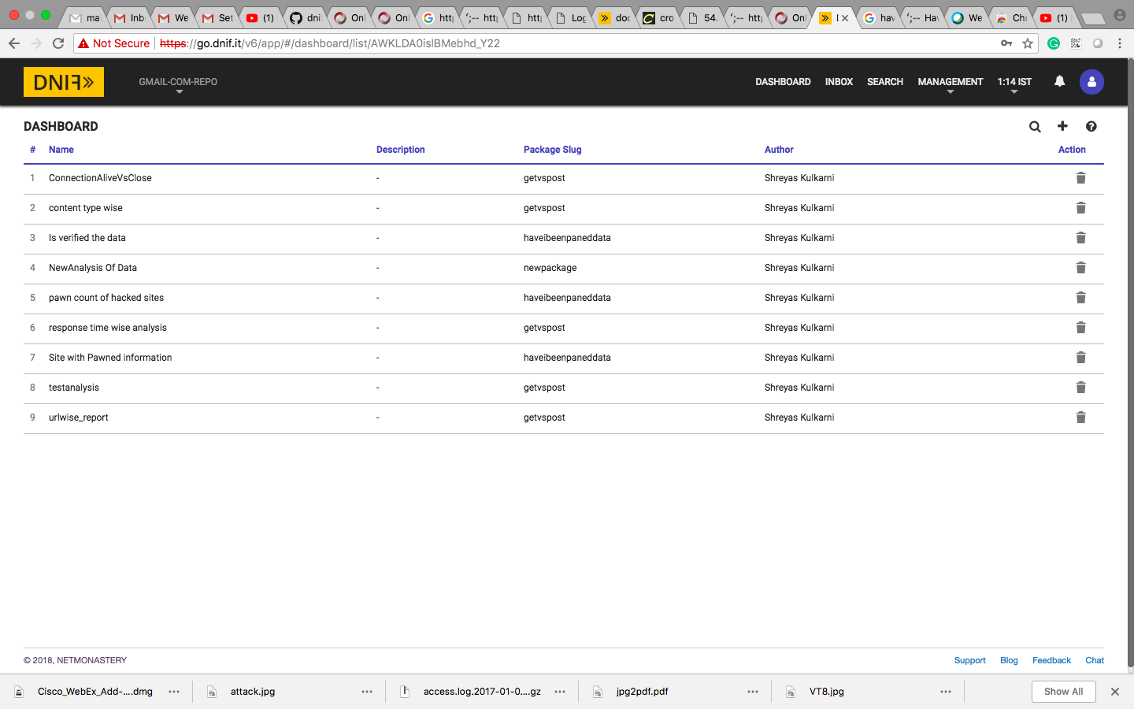

11. Now by clicking on your created analysis you created following screen.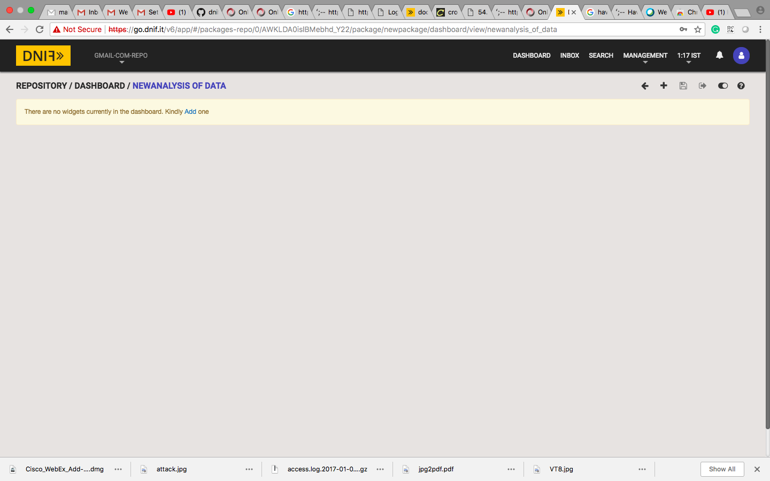

12. Now click on “Add” button of that screen you get following screen.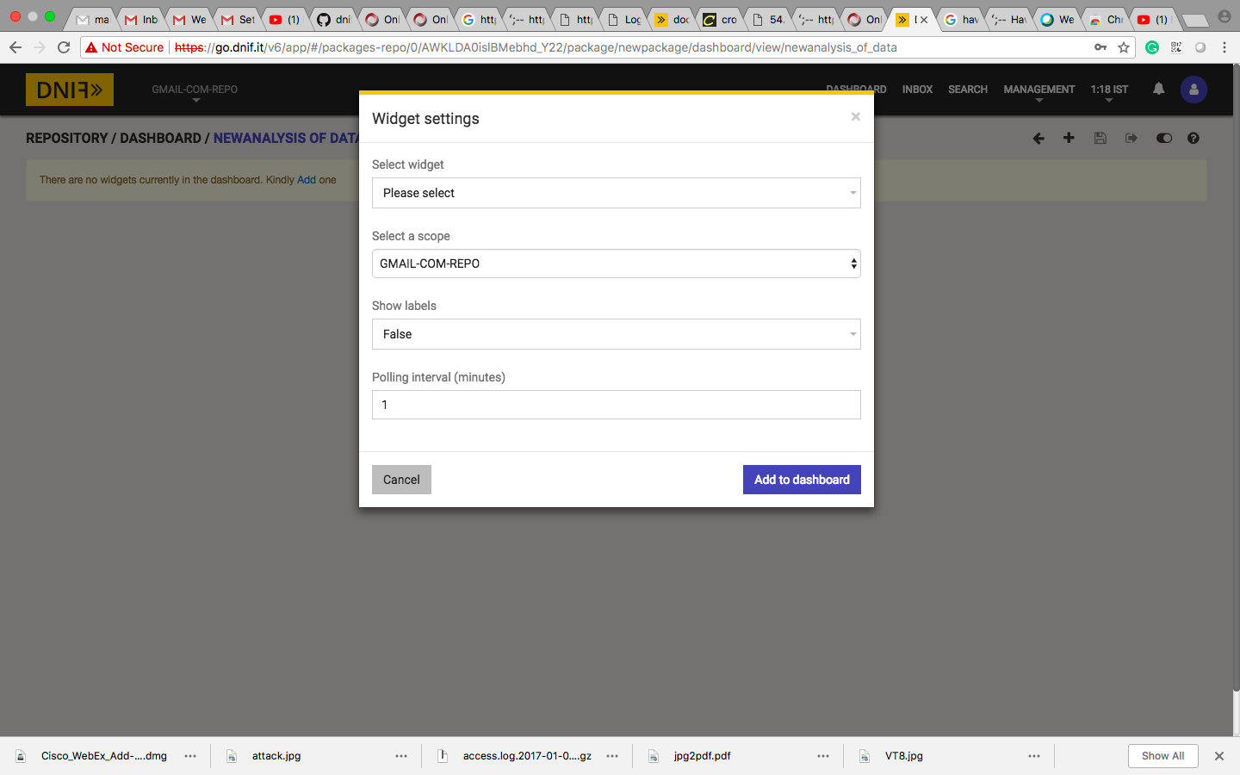

13. Now enter the all details of widget setting and click on add to dashboard.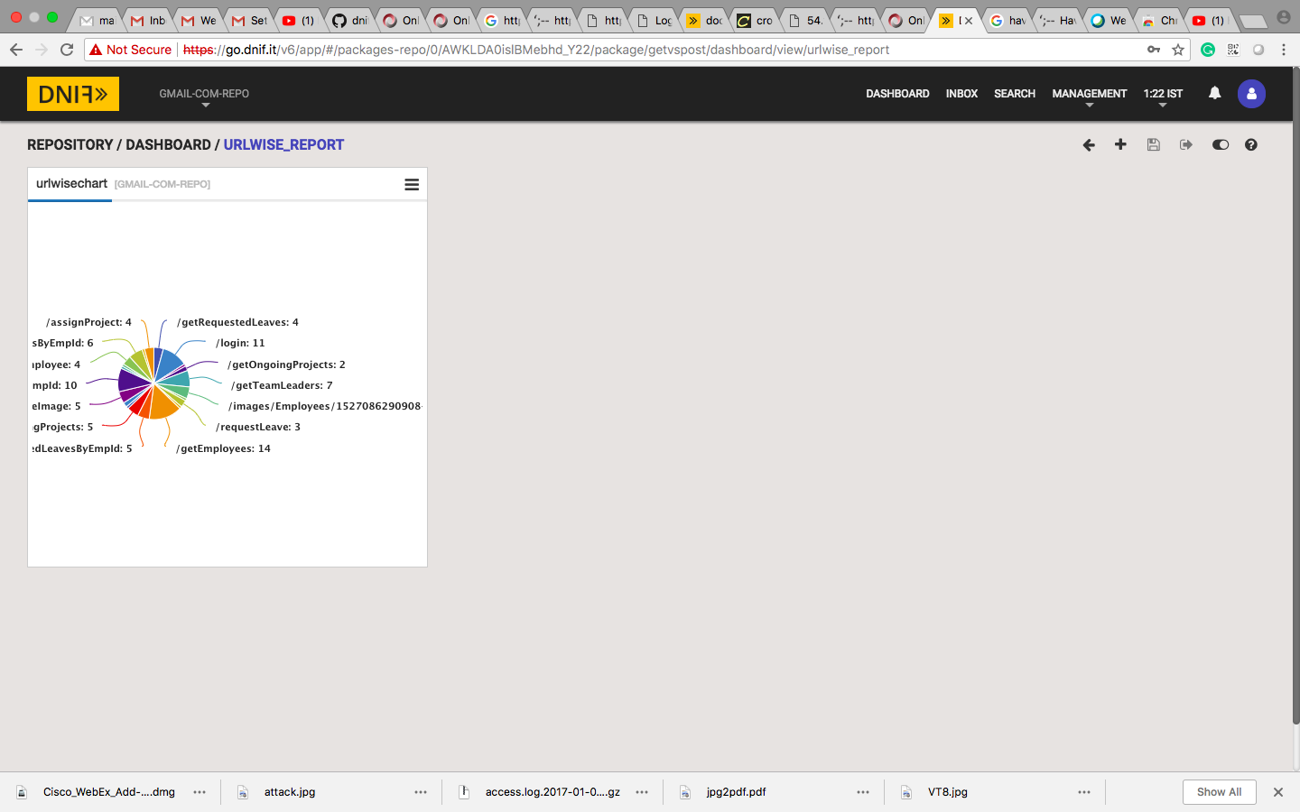

Now click on “save” button. Your dashboard is created.